**GIT Department of Computer Engineering**

**CSE 222/505 - Spring 2021**

**Homework 7 Report**

**Sena Erdoğan**

**1901042680**

1. **SYSTEM REQUIREMENTS**

* AVLorRedBlack method is the method to be called from outside. It returns 1 if the tree is a red black tree, 2 if it is an AVL tree and 0 if neither.
* isRedBlack method returns true if the tree is a red black tree.
* isAVL method returns true if the tree is an AVL tree.
* maxNodes method returns the maximum number of nodes an AVL tree can have according to its height.
* minNodes method returns the minimum number of nodes an AVL tree can have.
* maxHeight method returns the maximum height the AVL tree can have according to the number of nodes it has.
* minHeight method returns the minimum height the AVL tree can have.
* numberOfNodes method returns the number of nodes the tree has.
* heightOfTree method returns the height of the tree.

1. **USE CASE AND CLASS DIAGRAMS**

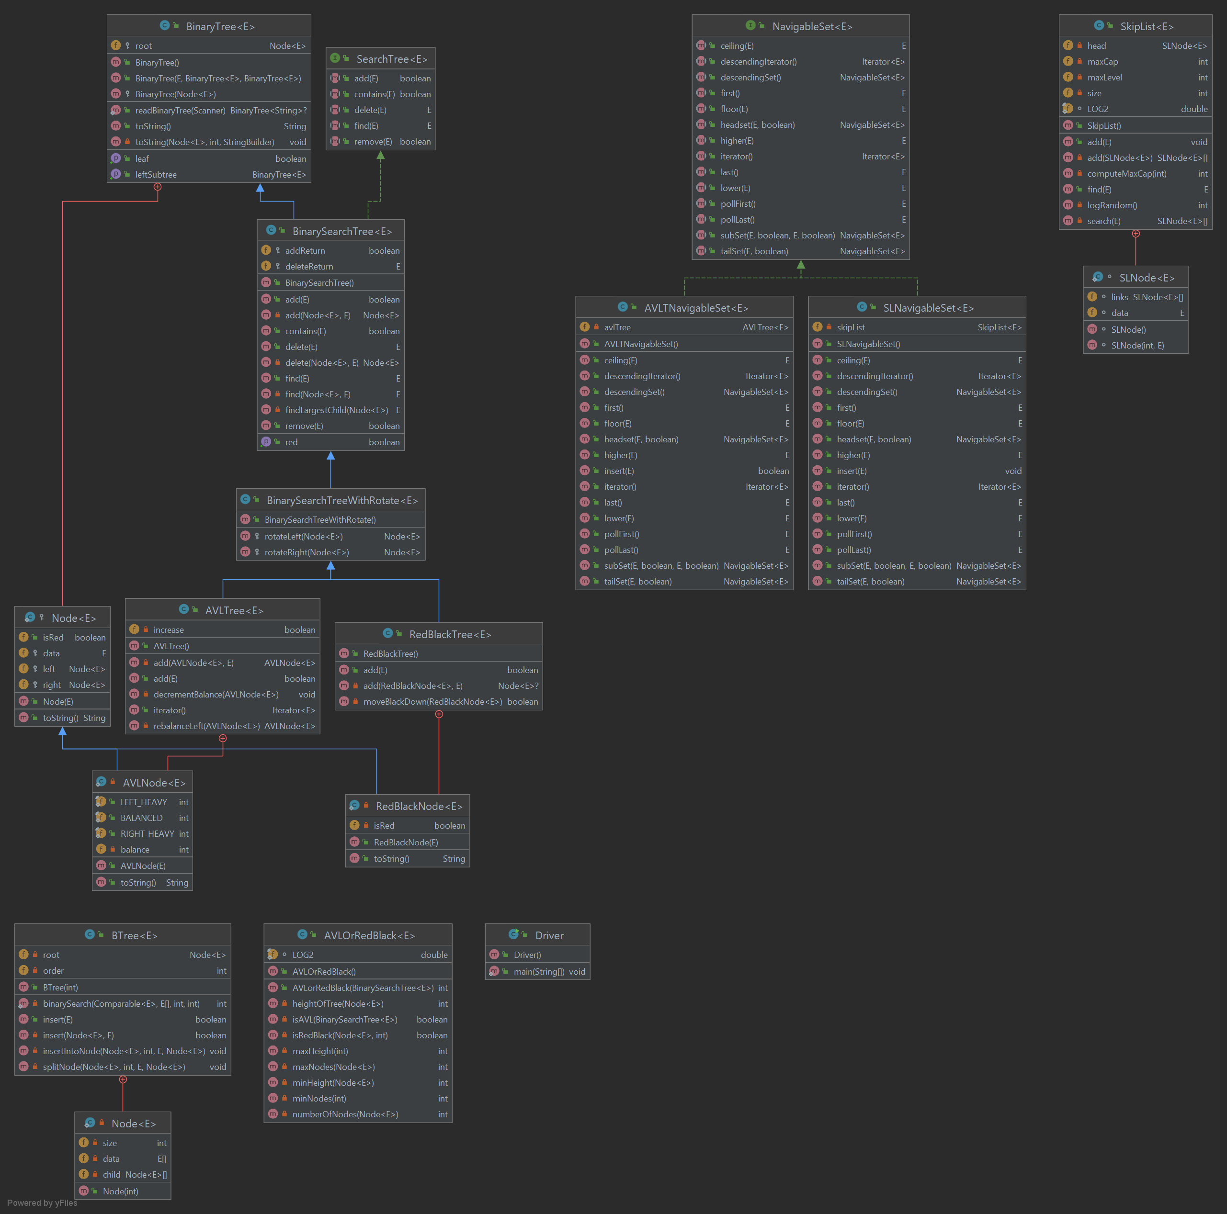

1. **PROBLEM SOLUTION APPROACH**

AVLorRedBlack method checks if the root of the tree is black. If it is not, that means the tree is not a red black tree and the method moves on the check if the tree is an AVL tree. If the root of the tree is black, the method calls isRedBlack method to check if the tree has the other requisites a tree needs to have in order to be a red black tree. If it does, the method returns 1. If it is not, and isAVL method is called, it checks if the number of nodes the tree has is between the minimum and maximum number of nodes an AVL tree can has according to its height and if the height of the tree is between the minimum and maximum height value an AVL tree can has according to its number of nodes.

The maximum number of nodes is calculated using the formula **2h+1 – 1, h being the height of the tree.**

**The minimum height of the tree is calculated using the formula ⌊log2n⌋, n being the number of nodes.**

1. **TEST CASES**

Every data structure has 40 instances. 10 of every data structure have 10000 Integers inserted, 10 of every data structure have 20000 Integers inserted, 10 of every data structure have 40000 Integers inserted and 10 of every data structure have 80000 Integers inserted.

1. **RUNNING AND RESULTS**        